S.No | Inside the Issue | Page No
1 | Vision,Mission,PEO & PSO of the Dept | 1
2 | User Experience Design | 2
3 | Placement Details | 3
4 | Students’ Achievements | 5
5 | Academic Performance | 6
6 | NPTEL Certifications | 7
7 | Faculty publications | 7
Vision of the Department
To evolve as a centre of academic excellence and advanced research in Computer Science and Engineering discipline.
Mission of the Department
- To inculcate in students a profound understanding of fundamentals related to discipline.
- To inculcate skills, attitudes and their applications in solving real world problems with an inclination towards societal issues and research.
- To promote research in the emerging areas of computer science and technology

Program Educational Objectives:
PEO1: Acquire strong foundation in the mathematical, scientific and engineering fundamentals necessary to formulate, solve and analyze engineering-problems.
PEO2: Develop the ability to analyze the requirements of the software, understand the technical specifications, design and provide novel engineering solutions and efficient software/hardware designs.
PEO3: Have exposure to emerging cutting edge technologies, adequate training & opportunities to work as teams on multidisciplinary projects with effective communication skills and leadership qualities.
PEO4: Have awareness on the life-long learning and prepare them for research development and consultancy.
PEO5: Have a successful career and work with values & social concern bridging the digital divide and meet the requirements of Indian and multinational companies.

Program Specific Outcomes

PSO1: Foundation of mathematical concepts: To use mathematical methodologies to crack problem using suitable mathematical analysis, data structure and suitable algorithm.
PSO2: Foundation of Computer System: the ability to interpret the fundamental concepts and methodology of computer systems. Students can understand the functionality of hardware and software aspects of computer systems.
PSO3: Foundations of Software development: the ability to grasp the software development lifecycle and methodologies of software systems. Possess competent skills and knowledge of software design process. Familiarity and practical proficiency with a broad area of programming concepts and provide new ideas and innovations towards research

Events Organised :
- Technical seminar on “User Experience Design” by Mr.Aravind Mohan Senior User Experience Architect,Mahindra City Development Centre,Infosys Ltd., Chennai was organized on 7.9.2019

Infosys Campus Connect of Saranathan College of Engineering has organized a Technical Seminar on “User Experience Design” on 7th Sep 2019. Mr.Aravind Mohan Senior User Experience Architect, Mahindra City Development Centre, Infosys Ltd., Chennai., has handled the sessions. Nearly 100 pre-final year students of CSE and IT took active participation.
The session started with the introduction to Software Testing and different ways to ensure that the software system is defect free. He also spoke on the classifications of testing such as Functional testing, Performance testing, Regression and Maintenance testing. Then he categorized and explained functional testing into Unit testing, Integration testing, Smoke, UAT (User Acceptance Testing) and Non functional testing into Performance, Endurance, Scalability, Usability. He has explained Agile development by correlating with the literal development process in Infosys.
Mr. Aravind, insisted strongly on the different types of software requirements that are needed to analyze the process of Software Testing. He suggested having the requirements in .xls (MSExcel) format so that it will be easy for the tester who will be testing the software in near future. He explained the statistics of employability in Development and Testing. Finally, he concluded by feeding tips to frame a resume of our own to appear for an interview and to succeed.

Placements details:
- The below listed have brought laurels to the department by grabbing placement offers from top corporate
S.No | Name of the Student | Company Placed
1 | ARUN KUMAR. S | Infosys(InfyTQ)
2 | DHINESH. T | Infosys(InfyTQ)
3 | DHIVAKAR. S | Infosys(InfyTQ)
4 | GOWRIGANEESH. K.S | Infosys(InfyTQ)
5 | IMMANUEL IRWIN. N | Infosys(InfyTQ)
 |  | Zoho(Cliqtrix)
6 | KEERTHIKA. S | Infosys(InfyTQ)
 |  | IVTL
 |  | TCS
7 | KISORE. S | Infosys(InfyTQ)
 |  | IVTL
 |  | TCS
8 | MOHAMED NABEEM. P | Infosys(InfyTQ)
 |  | TCS
9 | ROHIT RAJ | Infosys(InfyTQ)
10 | ALAGU. S | IVTL
 |  | TCS(CodeVita)
11 | RANJANI. K | IVTL
12 | VIGNESH. K | IVTL
 |  | TCS
13 | DHINESH KUMAR. S | TCS(CodeVita)
14 | JANANI. R | Infosys(HackWithInfy)
 |  | TCS
15 | BERYL SUSANNA B | TCS
16 | HARINI R | TCS
17 | NANDHAGOPALAKRISHNAN | TCS
18 | NIVETHA S | TCS
 |  | Infosys
19 | RAJAVIGNESH | TCS
 |  | Infosys
20 | SHEEBA AGNES C | TCS
 |  | Infosys
21 | SHIVAGAMI C | TCS
 |  | Infosys
22 | SOWMIYA S | TCS
 |  | Infosys
23 | VAISHNAVI M | TCS
24 | VINCY JOVITHA A | TCS
 |  | Infosys
25 | JOTHIKA S | TCS
 |  | Infosys
26 | JAYASHREE S | TCS
 |  | Infosys
27 | THAYALAN. G.R | VisualBI
28 | ARUNA. C | Infosys
29 | BHUVANESHRAJ. S | Infosys
30 | DEEPASHREE. M | Infosys
31 | JANANI. R | Infosys
32 | KALEESWARI. M | Infosys
33 | KEERTHANA. B | Infosys
34 | MADHUBALA. S | Infosys
35 | NIRMAL. R | Infosys
36 | PAVITHRA. J | Infosys
37 | PRAGADEESH. P | Infosys
38 | PRASANNA VENKATESH. R | Infosys
39 | RAJALAKSHMI. G | Infosys
40 | SHANMUGA PRIYA. R | Infosys
 |  | TCS
41 | SUHAIL YUSUFF AZEES. A | Infosys
42 | UMA MAHESWARI. T | Infosys
43 | AJAY D | Infosys
44 | KRITHIKA A | Infosys
45 | BALA KUMARAN. G | Infosys
46 | PRAKRITI. V | Infosys
47 | PRIYADHARSHINI. S | Infosys
48 | SRI GOPALA KRISHNAN. R | Infosys
49 | THENMOZHI. K | Infosys
50 | VENKAT RAMANAN. A.S | Infosys
51 | JOE EDWIN JAYARAJ. S | Zoho(Cliqtrix)
52 | FOUZIA | Zoho(Marketing)

Students Achievements:
- R Vatsala and Rohit raj of final year CSE - B has participated in the event RYLA 2019 was organised by ROTARY INTERNATIONAL DISTRICT 3000 at KODAIKANAL from 13th sep to 15th sep 2019
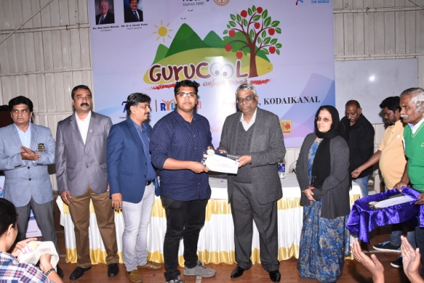
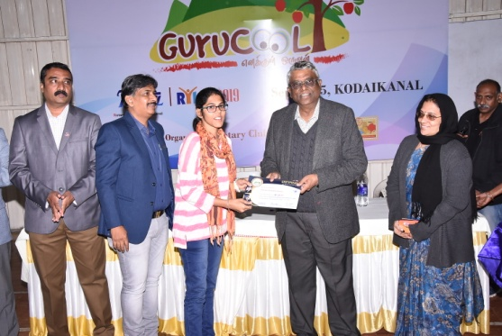

- V.Akilandeswari P.Krithiga R.Kesavpradha of III CSE has participated in Paper Presentation and Technical event organized by Dept of Computer Science and Engineering at Kongunadu College of Engineering and Technology on 9th Aug 2019 and won third Prize with the cash award of Rs 500
- R.Dharshini ,M.I.Hidhayarth Nisha of II CSE has participated and won First prize in Paper Presentation organized by Dept of Computer Science and Engineering at K.Ramakrishnan College of Engineering Trichy on 28th Aug 2019
- V. Varshini of III CSE has participated and won Second prize in Bug Breaker organized by Dept of Computer Science and Engineering at Coimbatore Institute of Technology on 28th Aug 2019
- Vishnu C, Harish V of II CSE has participated and secured First prize in Code Fest organized by Dept of Computer Science and Engineering at Coimbatore Institute of Technology on 28th Aug 2019
- S.P.Sanjay ,V.Krishnakumar has participated and secured First prize in Mask Coding organized by Dept of Computer Science and Engineering at Coimbatore Institute of Technology on 28th Aug 2019

- Vishnu C , Harish V has participated and secured First prize in Project Expo organized by Dept of Computer Science and Engineering at Saranathan College of Engineering on 13th & 14th Sep 2019

- R.Kesavapradha,S.P.Sanjay,B.Vigneshwaran,S.Sudharasan, M.Veeraharish,S.Vigneshraj,N.Vignesh,C.Vishnu,V.Harish,J.Infantremi has participated in technical events organized by Department of CSE at Coimbatore Institute of Technology on 28/9/2019

- S.Shriharini, S.Suvetha,K.Akila has participated in paper presentation event organized by Department of CSE at Kongunadu College of Engineering and Technology on 8/9/2019

Academic Performance

CSE department have achieved an overall of 81.37% of result in the odd semester.
ANNA UNIVERSITY EXAMINATION - NOV/DEC 2019
 |  | Before Review |  |  | After Review
Year | Sec | Total  Strength | All Clear  Students | AU Exam  Result | Total  Strength | All Clear  Students | AU Exam  Result
I Year  I Sem  (2019-2023 Batch) | A | 60 | 41 | 68.33 | 60 | 46 | 76.67
 | B | 59 | 43 | 72.88 | 59 | 50 | 84.75
 |  | 119 | 84 | 70.59 | 119 | 96 | 80.67
II Year  III Sem  (2018-2022 Batch) | A | 59 | 46 | 77.97 | 59 | 49 | 83.05
 | B | 56 | 42 | 75.00 | 56 | 44 | 78.57
 |  | 115 | 88 | 76.52 | 115 | 93 | 80.87
III Year  V Sem  (2017-2021 Batch) | A | 59 | 46 | 77.97 | 59 | 47 | 79.66
 | B | 59 | 40 | 67.80 | 59 | 44 | 74.58
 |  | 118 | 86 | 72.88 | 118 | 91 | 77.12
IV Year  VII Sem  (2016-2020 Batch) | A | 57 | 46 | 80.70 | 57 | 47 | 82.46
 | B | 58 | 51 | 87.93 | 58 | 53 | 91.38
 |  | 115 | 97 | 84.35 | 115 | 100 | 86.96
Overall % |  | 467 | 355 | 76.02 | 467 | 380 | 81.37

NPTEL Certifications by Faculty
- Dr.S.Mohana - Programming in Java
- Mr.S.Venkatasubramaniam - Demystifying networking
- Ms.R.Thillaikarasi -Introduction to programming in C
- Mr.K.S.Chandrasekaran- Practioners course in Descriptive, Predictive and Prescriptive Analytics and Database management systems
- Ms.R.SenthamilSelvi -Cloud computing
- Ms.N.Kavitha -The Joy of Computing using Python
- Mr.M.Anbazhagan-Python for Datascience
- Mr.A.T.Baranivijayakumar - Cloud computing
- Mr.R.Mohankumar - Python for Datascience
- Mr.P.Dineshkumar-Python for Datascience

Publications by Faculty
- S.Venkatasubramanian, Dr.A.Suhasini, Dr.C. Vennila, "A Review on achine Learning Techniques for QoS in WSN", International Journal of Advanced science and Technology, pp. 169-178, Vol. 28, Issue. 9, 2019, SCOPUS, Impact factor 0.13
- R.Thillaikarasi, "Detection of packet dropping nodes in Wireless Mesh Networks" in the proceedings of "Proceedings of Detection of packet dropping nodes in Wireless Mesh Networks" Organized by IIIT, Trivandrum on 2019. ISBN 978-981-15-3852-0, Springer, Singapore
- K.S.Chandrasekaran, "Measuring Performance Reliability of a system usimg DataMining" in the proceedings of "Proceeding of 11th International Conference on advanced computing (ICoAC 2019)". ISBM: 978-1-7281-5286-8
- R.Senthamil Selvi, "Enabling Data security in data using vertical split with parallel feature selection using meta heuristic algorithms", Concurrency and Computation: Practice and Experience, Issue. Special Issue, 2019, Impact Factor:1.114
- N.Kavitha, K.Rubasoundar,V.Balasubramaniam, "Intellectual Human-Object Classification Using Genetic Algorithm", Ieee Explorer, 2019 Advances In Science And Engineering Technology International Conferences, pp. 01-Jun, Vol. 1, Issue. 1, 2019
- M. Anbazhgan and Michael Arock, "Review rating prediction using combined latent topics and associated sentiments: an empirical review", Service Oriented Computing and Applications (Springer - ESCI), pp. 19â€“34, Vol. 14, Issue. 1, Nov 2019
- Dr.PL.Rajarajeswari, "Fair Adaptive Cross-Layer Resource Allocation Scheme for IEEE 802.16 Broadband Wireless Networks", Wireless Personal Communications, pp. 1-22, Vol. 1, Issue. 1, NOV 2019

FACULTY EDITOR

J.SathiaParkavi, AP/CSE

